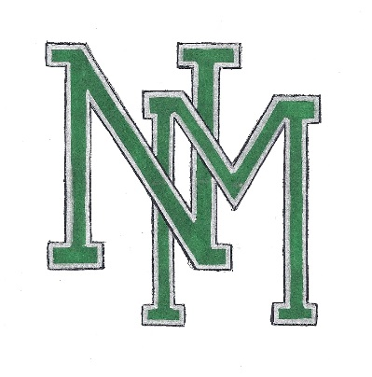
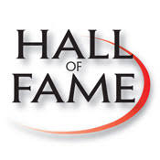
NMHS ATHLETIC HALL of FAME MEMBERS
(UPDATED 6/15/18)

Michael Janis 1962
Dan Morrisey 1962
Kenny Orr 1962
Robert Bedell 1964
Bill Newcomb 1964
Lloyd Preissler 1964
Bob Flanagan 1965
Joe Cervino 1967
Dr. Brian Gross 1967
Jeff Kalish 1967
Charles O'Hanlon 1967
Dale Faust 1968
Dr. Jeff Fried 1968
Ed Marinaro 1968
Randy Sokolik 1969
Dave Finkelstein 1970
Eric Huettinger 1971
Dr. Craig Rosen 1971
Dr. John Spieker 1971
Ken Nelson 1972
Brian Small 1973
John Carroll 1973
Jeff Sokolik 1973
Ken Stokes 1974
Tom Cervino 1975
Terry Lafferty 1975
Gwenn Ghiosay 1977
Mario Marquez 1977
Karen Peterman 1977
Joliene Boenau 1979
Eileen MacMaster 1979
Mike Muratore 1979
Lisa Crystal 1980
Gary Elefante 1980
Bill Maro 1981
Carolyn Bachmann 1982
Kim Gillman 1982
Lloyd DeNicolo 1984
Dayna Myers 1984
Trich Neuner 1984
Barry Swanson 1984
Sheila Clancy 1985
Rich O'Brien 1985
Steven Truglio 1985
Raffy Daghlian 1986
Diano Maro 1986
Dave Simon 1986
Doug Brown 1987
Susan Esposito 1987
Scott Jacob 1987
Mike McSherry 1987
Ralph Orta 1987
Lynn Petrolia 1987
Moira Rooney 1987
Chris Boyle 1988
David Lane 1989
Gerald Perrone 1990
Jeff Heal 1991
Shannon Dillon 1993
Jim Toth 1964
William Waterfall 1967
Steve Ferretti 1967
Martin Lomascola 1967
Bruce Strauss 1968
James Hennessey 1969
Ken Clark 1969
Bob Sturges 1965
Charles Koenke 1990
John Alise 1992
Jackie Albanese 1995
Nina Bustos 1996
Todd Lanchart 1996
Mike Murphy 1999
Arthur Caughlin 1965
Robert Chester
Larry Mash
Charles Boyle
Dorothy Jabel
Les Plumb
Pete Ferretti
Shirley O'Brien
Philip Klocek
Ray Harrison
Steven Day
Joseph R. Toth
Joseph Hess
Donald W. Rickert
William Hartney
Daniel P. Shockloss
Bill C. Monaghan
Marie (Sandy) Ross
Lou Coco
John Dombrowski
Lou Capozzi
Dennis Calacione 2018
Todd Crispino 2018
PJ Saporito 2018
Joanne Tiu 2018
Vivian Davis 2018
Mr. & Mrs. DeMiglio 2018

Dr. John Spieker
1966 Baseball Team
1967 Wrestling Team
1967/68/69 Track Teams
1986/1987 Baseball Team
1991 Wrestling Team
1995 Girls Soccer Team
1970 Wrestling Team
1972 Football Team
1977 Baseball Team
1977 Softball Team
1985 Football Team
1986 Football Team
1986 Girls Track Team
1987 Girls Track Team
1988 Soccer Team
1982 Girls Tennis Team 2018
2004 Baseball Team 2018

